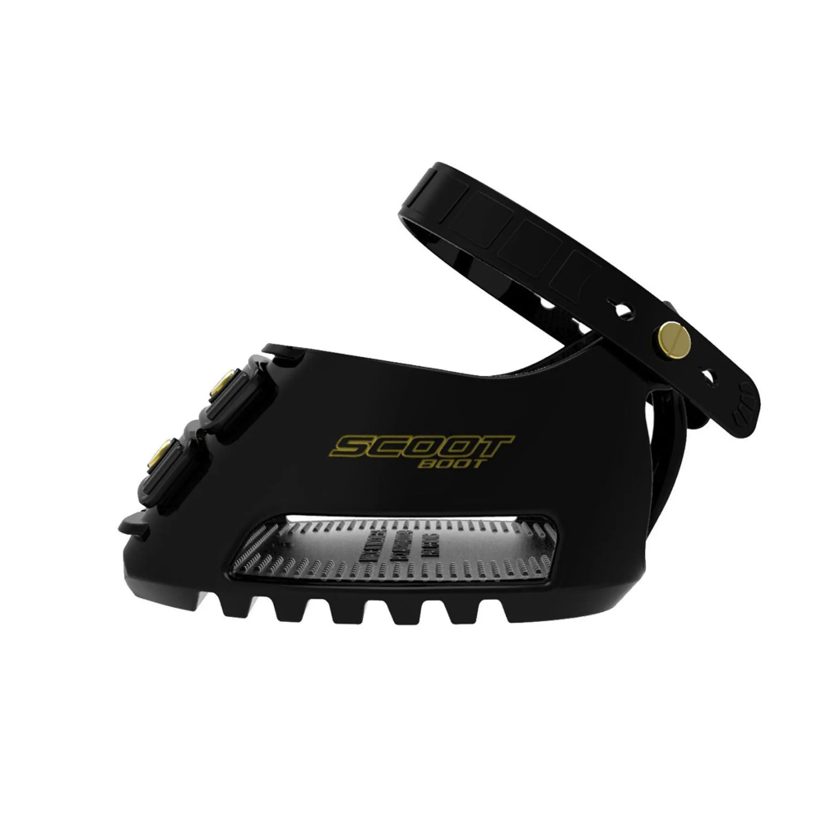

**Scoot Boots (Pair)**

RRP $282

Horse ‘N’ Around Mulgoa $265

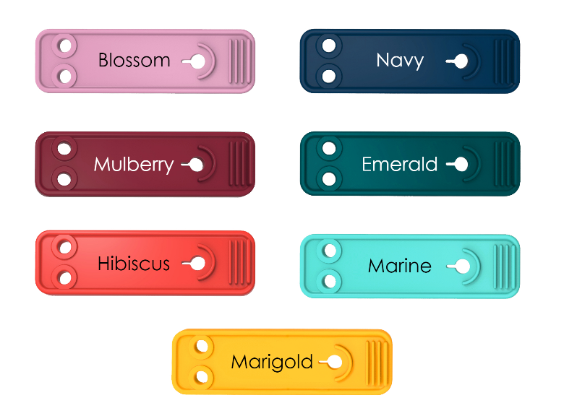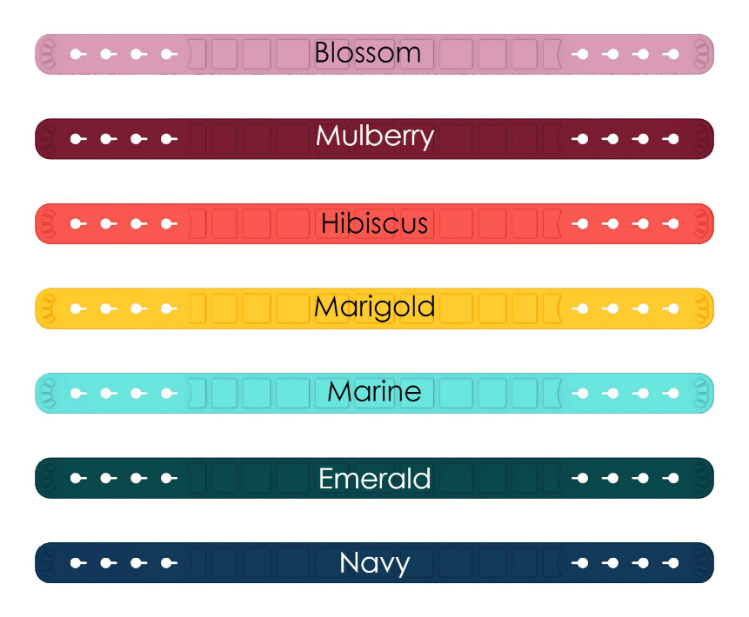

**Coloured Front Straps**

RRP $28

Horse ‘N’ Around Mulgoa $25

**Coloured Pastern Straps**

RRP $22

Horse ‘N’ Around Mulgoa $20

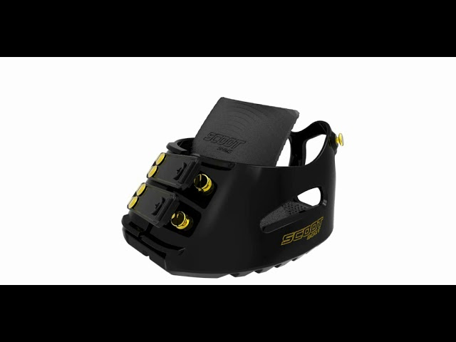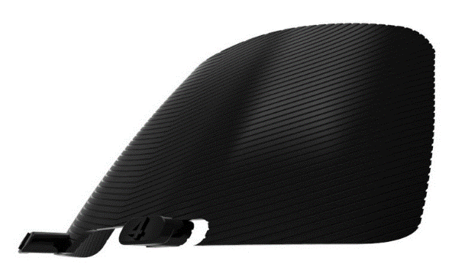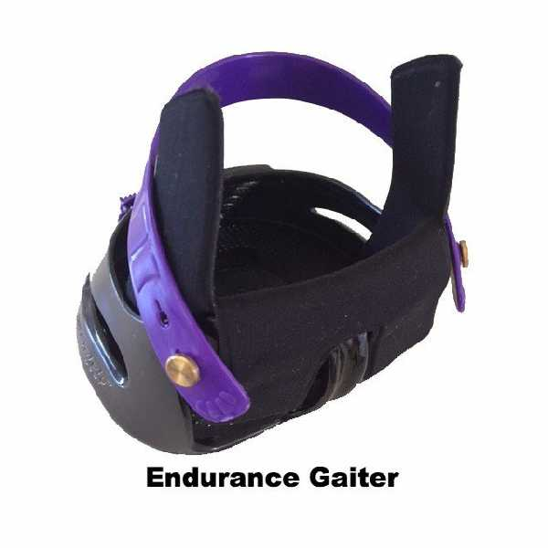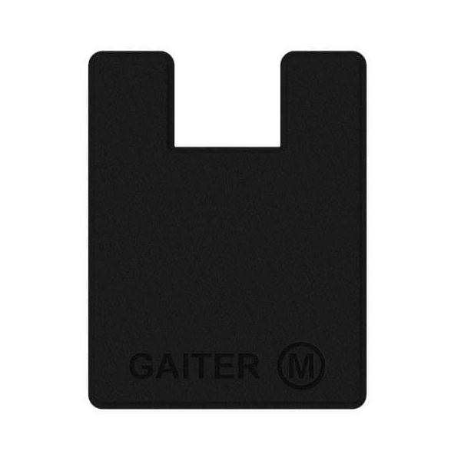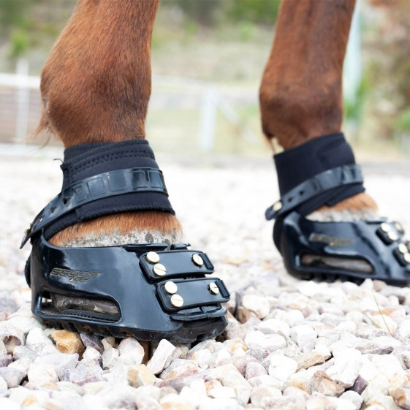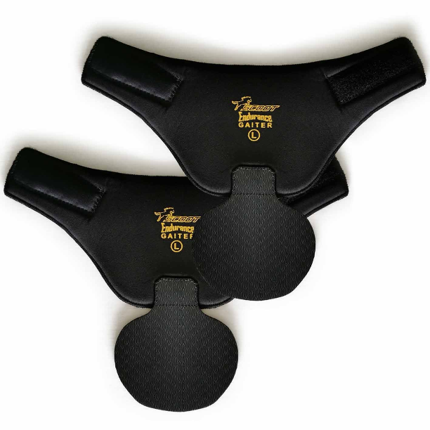

**Anti Slip Shims**

RRP $24

Horse ‘N’ Around Mulgoa $22

**Tail Gaiter Pack**

RRP $33

Horse ‘N’ Around Mulgoa $30

**Endurance Gaiters**

RRP $40

Horse ‘N’ Around Mulgoa $38

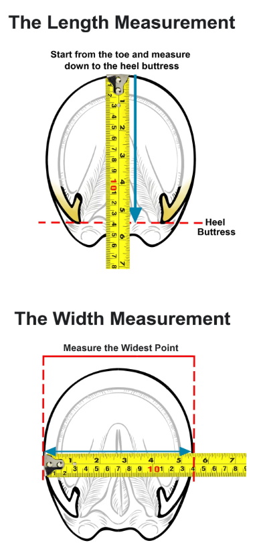

PLEASE NOTE:

Measure each horse's hoof within 2 weeks of a barefoot trim

